Abstract
This project implements a custom, auditable data-cleaning pipeline for the Women's Clothing dataset. The pipeline automatically detects exact duplicate records and structurally irrelevant columns, records the reason for each proposed action, protects critical analytical fields, creates recoverable backups, and validates the result before export. The original data contained 23,486 rows and 11 columns. Once the generated index column was excluded from record comparison, 21 redundant duplicate copies were found. The pipeline removed those copies and the irrelevant index column, producing a validated dataset of 23,465 rows and 10 meaningful columns.
Outcome: 99.91% of rows were retained, no duplicate rows remained, and every critical analytical column was preserved.

Key Results
Measure | Before | After | Decision
Rows | 23,486 | 23,465 | 21 redundant copies removed
Columns | 11 | 10 | 'Unnamed: 0' removed
Exact duplicate copies | 21 | 0 | First occurrence retained
Critical columns | 10 | 10 | All protected

1. Introduction
Fashion-industry analysis depends on reliable records. Duplicate customer reviews can inflate product activity, rating frequencies and recommendation counts, while irrelevant columns can add noise and hide data-quality problems. Cleaning must therefore remove confirmed redundancy without deleting valid repeated activity, such as several customers reviewing the same Clothing ID.
The task addressed in this report is to remove duplicate rows and irrelevant columns through a reusable pipeline that detects and logs redundant data while ensuring that critical information is preserved.

2. Problem Statement and Objectives
Problem statement. The raw CSV contains a generated row-number column and repeated records that are not visible when all columns are compared directly. A safe solution must distinguish true duplicate records from valid repeated product identifiers and provide evidence for every removal.

2.1 Objectives
ID | Objective
O1 | Audit the dataset structure, data types, missingness and uniqueness.
O2 | Automatically detect index-like, empty, constant and copied columns.
O3 | Detect exact duplicate rows using meaningful business columns.
O4 | Protect critical analytical columns from automatic deletion.
O5 | Back up removed data and create a transparent cleaning log.
O6 | Validate row counts, schema, unique information and saved output.

3. Dataset Description
The source file contains customer reviews and product-classification attributes used to study women's clothing preferences and feedback. It has 23,486 observations and 11 columns before cleaning.
Column | Type | Missing | Unique
Unnamed: 0 | int64 | 0 | 23,486
Clothing ID | int64 | 0 | 1,206
Age | int64 | 0 | 77
Title | object | 3,810 | 13,993
Review Text | object | 845 | 22,634
Rating | int64 | 0 | 5
Recommended IND | int64 | 0 | 2
Positive Feedback Count | int64 | 0 | 82
Division Name | object | 14 | 3
Department Name | object | 14 | 6
Class Name | object | 14 | 20

Missing values were audited but were not altered, because the assigned task focuses on duplicate rows and irrelevant columns. Title, Review Text and classification fields therefore remain available for a separate missing-value treatment if required.

4. Methodology
A conservative pipeline was designed around detection, protection, backup, removal and verification. Safe automatic removal is limited to clearly redundant structures. Ambiguous fields are retained for manual review.
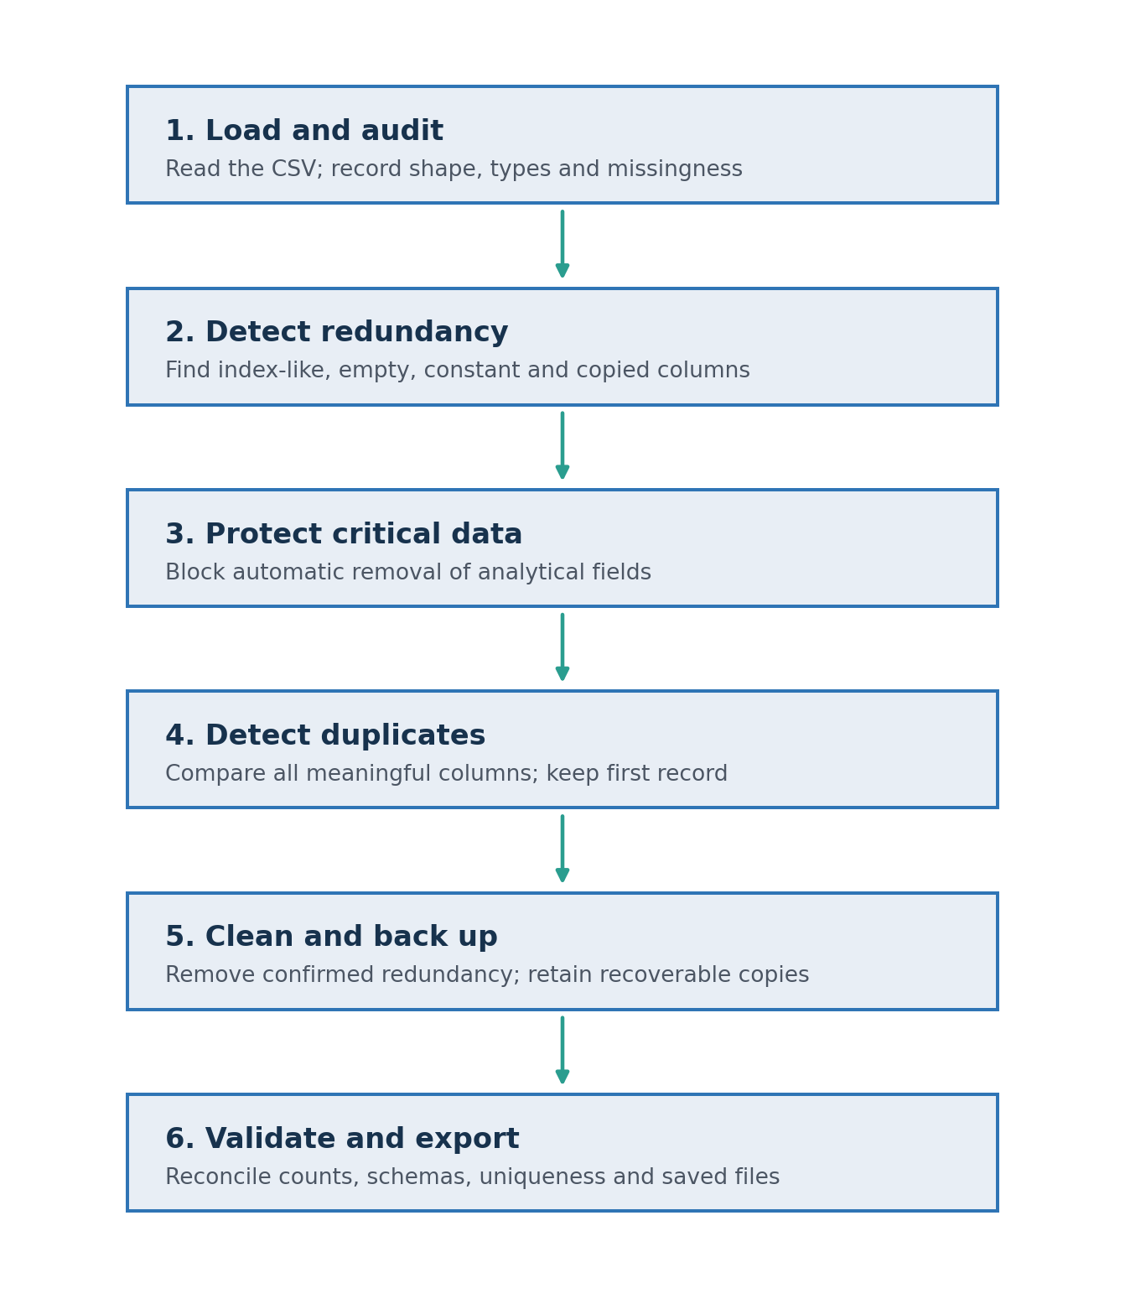
Figure 1. Custom data-cleaning pipeline
Check | Detection rule | Pipeline action
Index-like columns | Name begins with Unnamed or values equal 0..n-1 | Safe if not critical
Empty columns | Every value is missing | Safe if not critical
Constant columns | One value including missingness | Safe if not critical
Copied columns | Series equals an earlier column | Keep original; review critical copy
Duplicate rows | All meaningful fields match | Keep first; back up extra copy

4.1 Critical Information Safeguard
Ten meaningful fields were declared critical: Clothing ID, Age, Title, Review Text, Rating, Recommended IND, Positive Feedback Count, Division Name, Department Name and Class Name. If any critical field is marked for automatic removal, the pipeline stops with an error instead of continuing.
Key interpretation: A repeated Clothing ID is not a duplicate by itself. One garment can legitimately receive many different customer reviews.

5. Implementation
The solution was implemented in Python using pandas and NumPy. The program separates detection from mutation: it first produces candidate lists and logs, then performs removals only after the safety checks pass. The original DataFrame remains unchanged; the result is stored in a separate cleaned DataFrame.

5.1 Core Duplicate Logic
comparison_columns = [
c for c in data.columns
if c not in safe_removal_columns
]
removable_mask = data.duplicated(
subset=comparison_columns,
keep='first'
)
removed_rows_backup = data.loc[removable_mask].copy()
cleaned_data = data.loc[~removable_mask].copy()

5.2 Logging and Backup Design
The pipeline returns the cleaned dataset, duplicate-row backup, removed-column backup, cleaning summary, column-detection report, safe-removal list and manual-review list. This design provides an audit trail and supports recovery if a decision must later be reversed.

6. Results
The generated index column initially made the full-row duplicate count appear to be zero because its value was unique in every row. After excluding that column, 42 records were found inside 21 duplicate pairs. One record from each pair was retained, so 21 extra copies were removed.
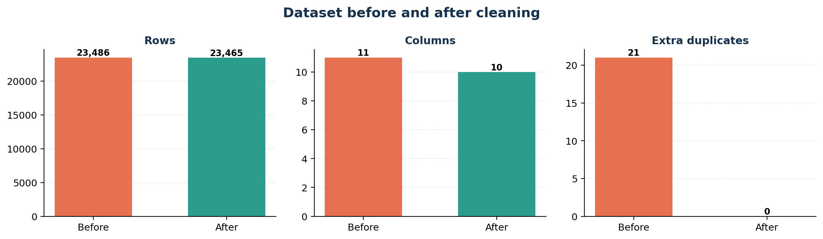
Figure 2. Before-and-after cleaning comparison
Result metric | Observed value
Original shape | 23,486 x 11
Irrelevant column detected | Unnamed: 0
Rows in duplicate groups | 42
Extra duplicate copies removed | 21
Final shape | 23,465 x 10
Row retention | 99.91%
Duplicates remaining | 0

7. Validation and Information-Loss Control
Validation compared the pipeline result with a manually constructed expected result obtained by removing only the confirmed irrelevant column and retaining the first occurrence of each exact meaningful record. The two DataFrames matched exactly.
Validation check | Evidence | Status
Row-count reconciliation | 23,486 - 21 = 23,465 | Passed
Expected-content equality | Pipeline output equals expected DataFrame | Passed
Critical-column preservation | 10 of 10 critical columns present | Passed
Data-type preservation | All retained types unchanged | Passed
Unique-information preservation | Unique counts retained for all critical fields | Passed
Remaining duplicates | 0 | Passed
Remaining irrelevant columns | 0 | Passed

8. Discussion
The cleaning changes are small in volume but important in meaning. Only 0.09% of rows were removed, which indicates that the dataset was generally well structured. However, leaving the 21 repeated records would slightly overstate the frequency of their associated products, ratings and recommendations. Removing the generated index also prevents it from being treated as a predictive feature or analytical variable.
The strongest feature of the solution is its conservative decision policy. It does not delete columns merely because they contain missing values or repeated identifiers. Instead, removal is restricted to structural redundancy, while critical fields are explicitly protected and all changes are logged.

9. Limitations
Limitation | Implication
Exact matching | The pipeline detects exact duplicates; near-duplicate reviews with spelling or punctuation differences require text-similarity methods.
Business rules | Critical-column selection is project-specific and should be reviewed if the analysis objective changes.
Missing values | Missing-data imputation is outside this task and should be handled in a separate validated stage.
Source identity | No customer identifier is present, so repeated reviews cannot be assessed at an individual-customer level.

10. Conclusion and Recommendations
The project successfully delivered a reusable custom data-cleaning pipeline for the Women's Clothing dataset. The pipeline detected one irrelevant sequential index column and 21 redundant duplicate copies, created backups and logs, removed only confirmed redundant data, and validated the cleaned output. The final dataset contains 23,465 rows and 10 meaningful columns, with zero remaining exact duplicates and all critical information preserved.
For future work, the same pipeline should be executed before exploratory analysis or model development. Additional stages may be added for missing-value imputation, text normalization and near-duplicate detection, but each should retain the same detect-log-protect-validate pattern.
Final status: Project task completed successfully. The cleaned dataset is ready for reliable fashion-trend and customer-feedback analysis.

References
Source | Reference
Dataset | Women's Clothing E-Commerce Reviews CSV supplied for this project.
pandas | https://pandas.pydata.org/docs/
NumPy | https://numpy.org/doc/
Matplotlib | https://matplotlib.org/stable/

Appendix A: Reusable Pipeline Outline
The following condensed function shows the central orchestration logic. Detection helper functions produce the safe-removal list and duplicate mask before any mutation is performed.
def custom_data_cleaning_pipeline(data, critical_columns):
working_data = data.copy(deep=True)
report, safe_columns, review_columns = \
detect_irrelevant_columns(working_data, critical_columns)
at_risk = [c for c in safe_columns if c in critical_columns]
if at_risk:
raise ValueError(f"Critical columns at risk: {at_risk}")
duplicate_result = detect_duplicate_rows(
working_data,
ignored_columns=safe_columns
)
removable = duplicate_result["removable_mask"]
row_backup = duplicate_result["removed_rows_backup"]
column_backup = working_data[safe_columns].copy()
cleaned = working_data.loc[~removable].copy()
cleaned = cleaned.drop(columns=safe_columns, errors="ignore")
cleaned = cleaned.reset_index(drop=True)
if cleaned.duplicated().sum() != 0:
raise ValueError("Duplicate validation failed")
if any(c not in cleaned.columns for c in critical_columns):
raise ValueError("Critical-column validation failed")
return {
"cleaned_data": cleaned,
"removed_rows_backup": row_backup,
"removed_columns_backup": column_backup,
"column_detection_report": report,
"manual_review_columns": review_columns,
}

Appendix B: Deliverables
File | Purpose
womens_clothing_cleaned.csv | Validated dataset for analysis
removed_duplicate_rows_backup.csv | Recoverable copies of the 21 removed records
removed_columns_backup.csv | Backup of the removed sequential index
cleaning_summary_log.csv | Before-and-after counts and decisions
column_detection_report.csv | Column-level reason and removal status
validation_report.csv | Pass/fail evidence for safety checks
cleaning_before_after_comparison.png | Visual summary of cleaning results

Appendix C: Submission Checklist
No. | Submission check | Status
1 | Run every notebook cell in order | Complete
2 | Confirm final shape is 23,465 x 10 | Complete
3 | Confirm remaining duplicate count is zero | Complete
4 | Keep cleaned data, backups and logs together | Complete
5 | Attach the before-and-after chart | Complete
6 | Fill course, institution and evaluator details on cover | Before submission

Appendix D: Recommended Notebook Order
Present the notebook in this order: data loading, detailed audit, irrelevant-column detection, duplicate detection, pipeline execution, validation, file export and final visualization. Keeping this sequence makes the analysis reproducible and easy to evaluate.

